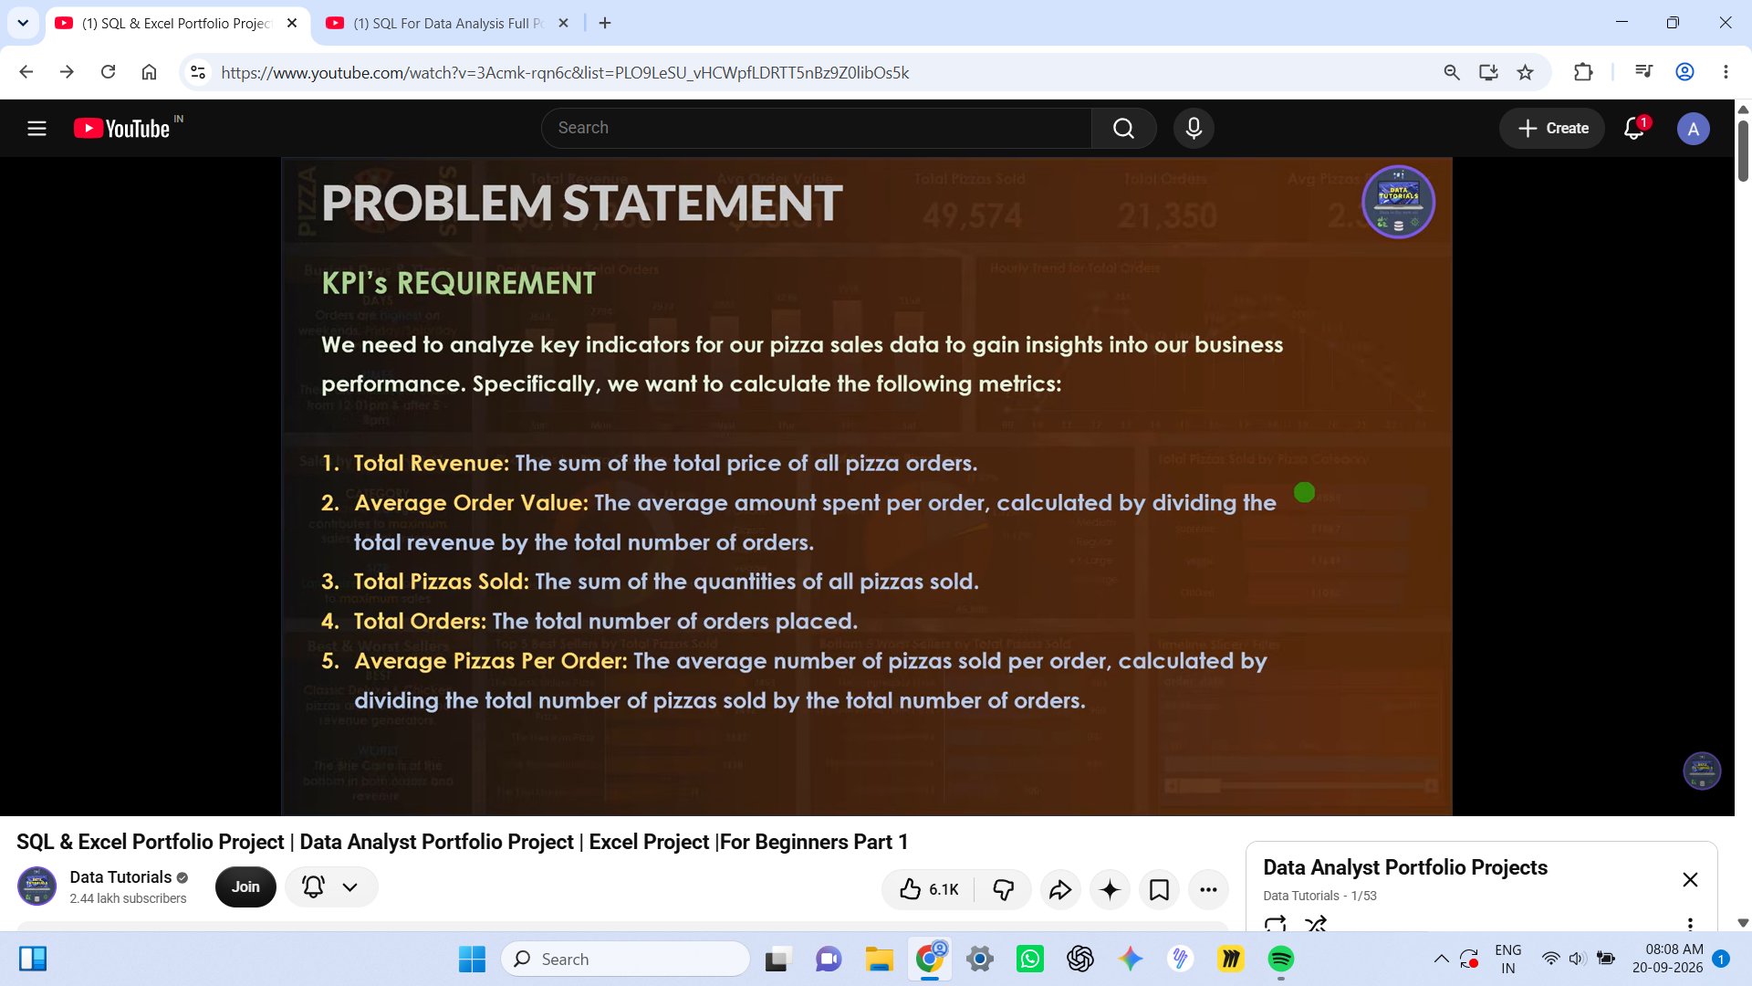

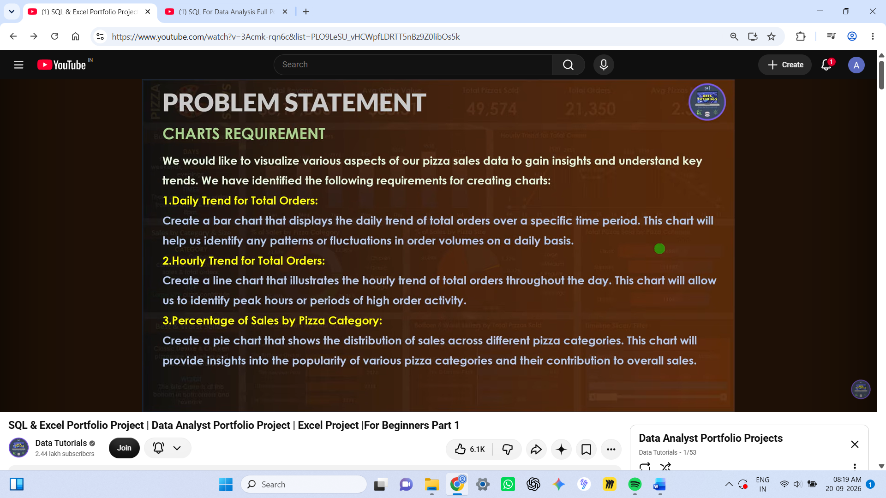

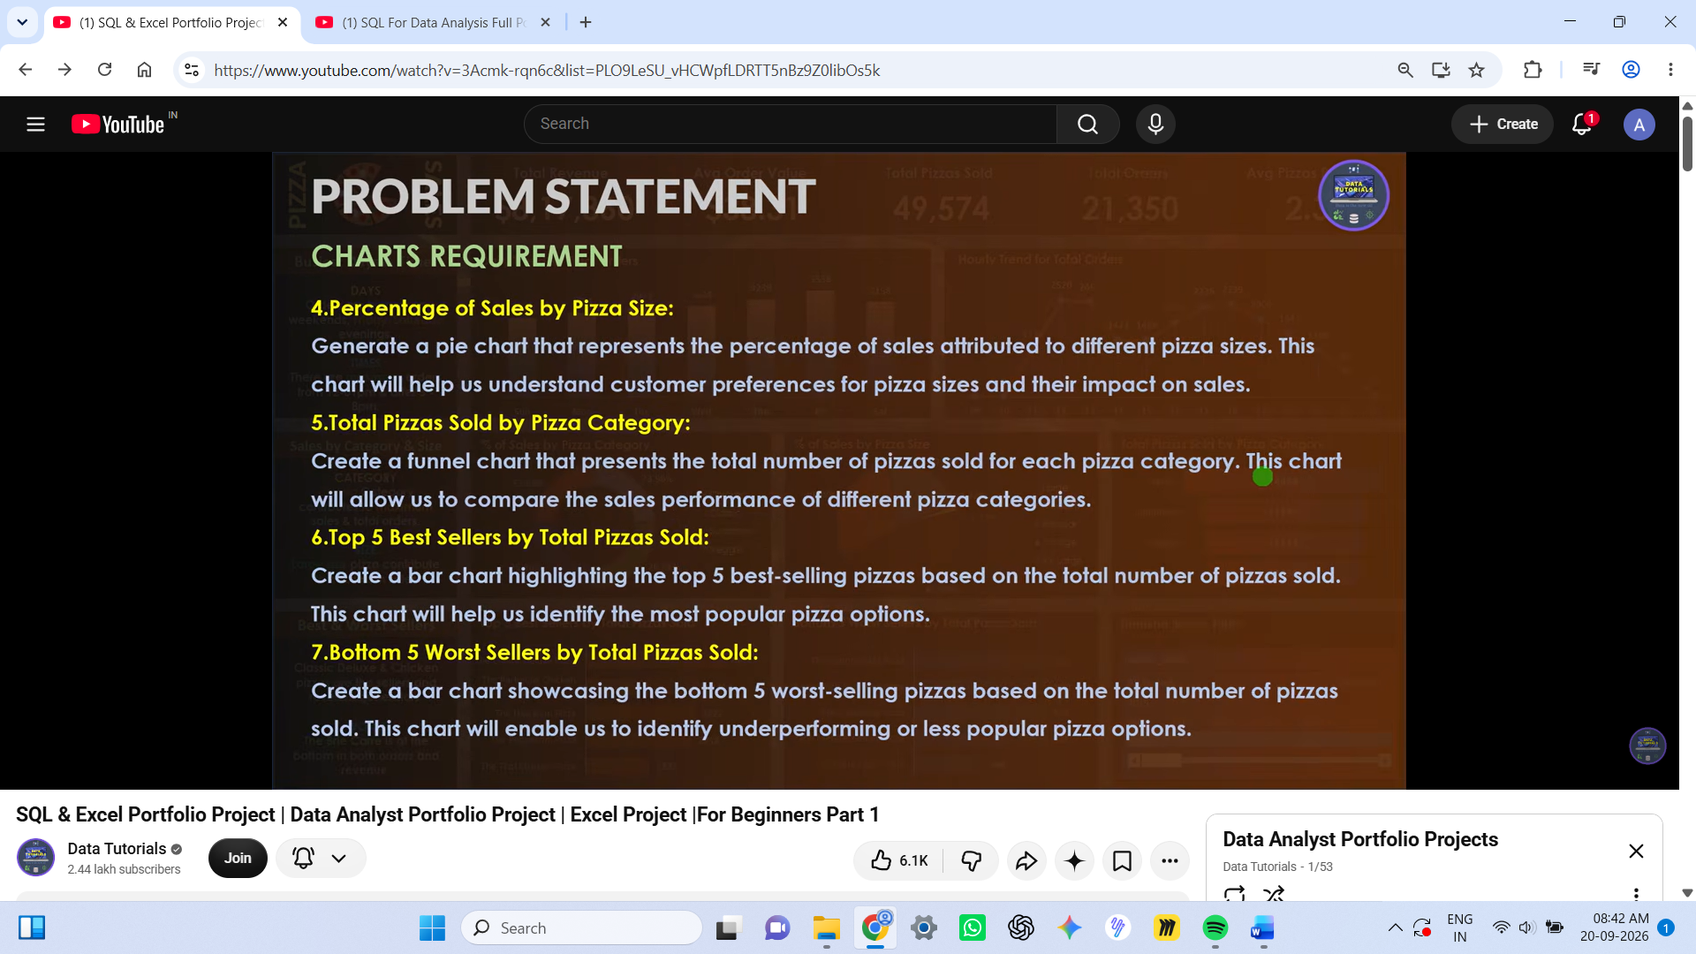

SQL QUERIES FOR KPI’s:

-- 1. Total Revenue
Select SUM (total_price) as Total_Revenue from pizza_sales;

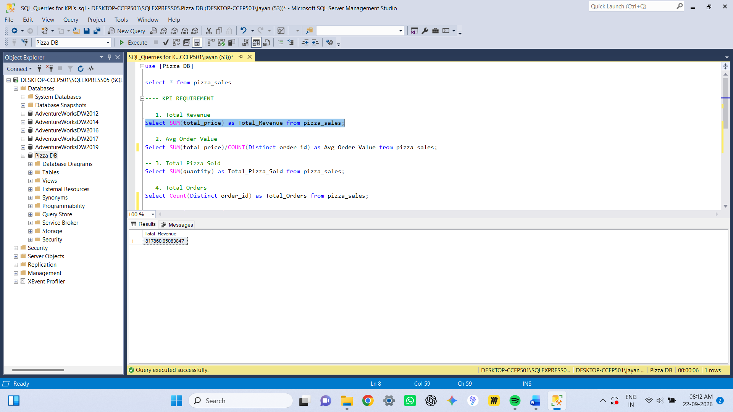

-- 2. Avg Order Value
Select SUM (total_price)/COUNT (Distinct order_id) as Avg_Order_Value from pizza_sales;

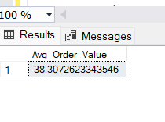

-- 3. Total Pizza Sold
Select SUM (quantity) as Total_Pizza_Sold from pizza_sales;

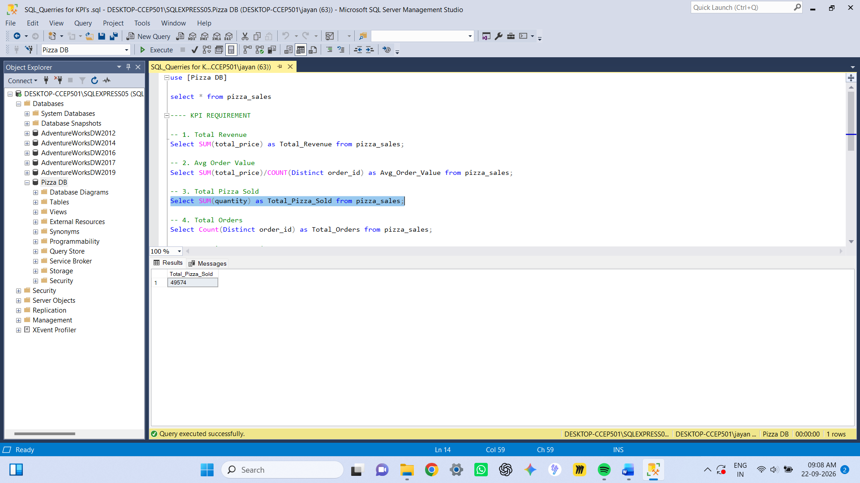

-- 4. Total Orders
Select Count (Distinct order_id) as Total_Orders from pizza_sales;

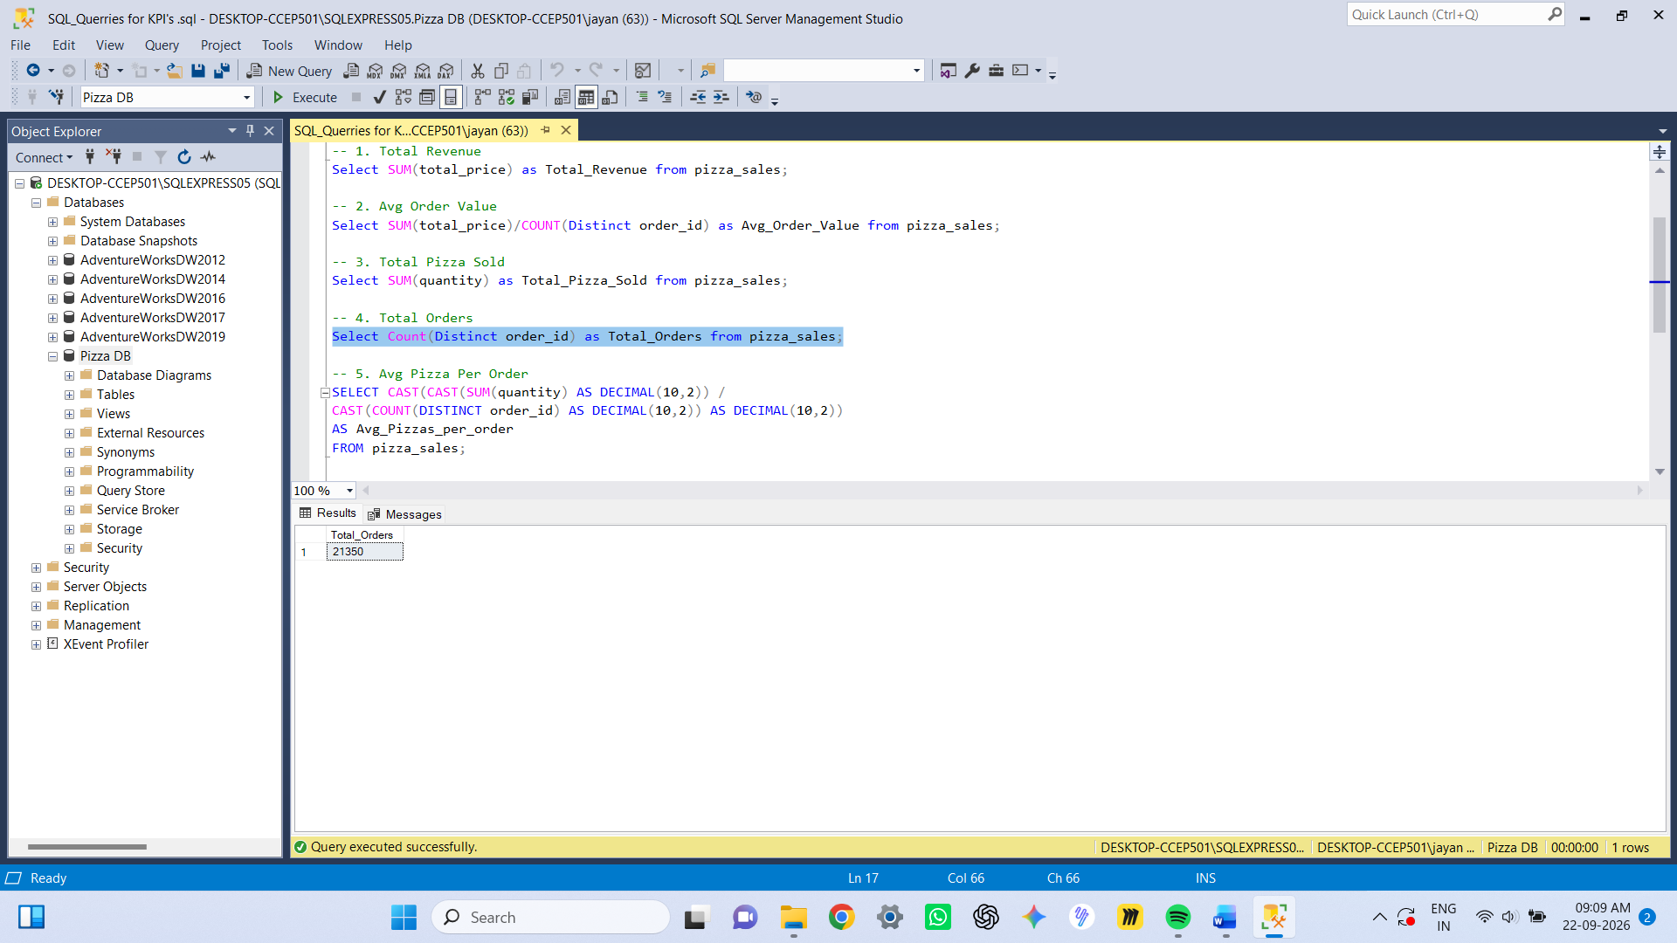

-- 5. Avg Pizza Per Order
SELECT CAST (CAST (SUM (quantity) AS DECIMAL (10,2)) /
CAST (COUNT (DISTINCT order_id) AS DECIMAL (10,2)) AS DECIMAL (10,2))
AS Avg_Pizzas_per_order
FROM pizza_sales;

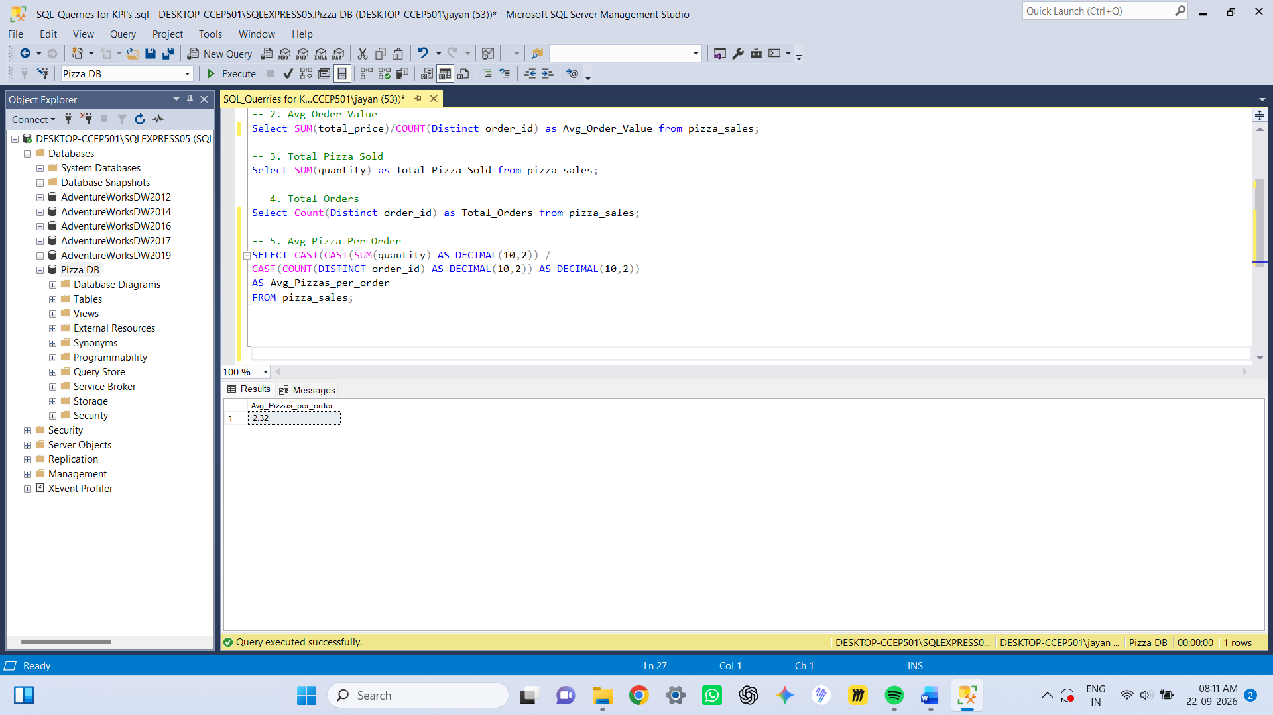

SQL QUERIES FOR PIVOT TABLES’s:

-- 1. Daily Trend for Total Orders

Select Datename(DW, order_date) as Order_day,
Count (Distinct order_id) as Total_Orders
from pizza_sales
Group by Datename(DW,order_date);

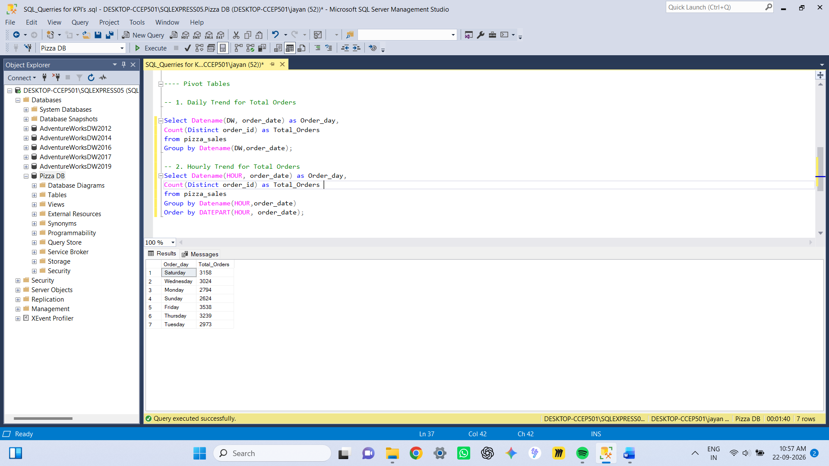

-- 2. Hourly Trend for Total Orders
Select DATEPART (HOUR, order_time) as Order_Hours,
Count (Distinct order_id) as Total_Orders
from pizza_sales
Group by DATEPART(HOUR,order_time)
Order by DATEPART (HOUR, order_time);

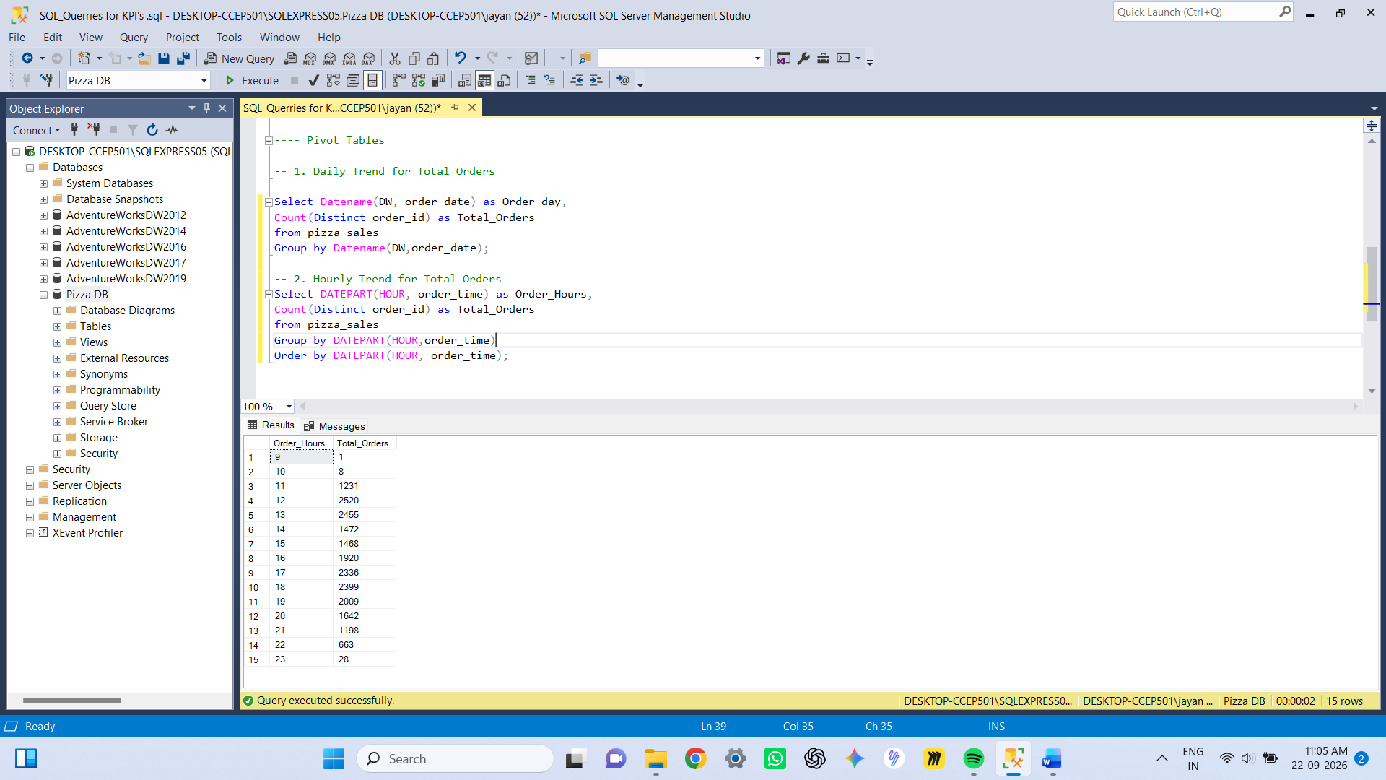

-- 3. % of Sales by Pizza Category

Select pizza_category, CAST (SUM (total_price) as decimal (10,2)) as Total_Revenue,
CAST (SUM (total_price) * 100 / (Select SUM (total_price) from pizza_sales) as decimal (10,2)) as PCT
from pizza_sales
Group by pizza_category

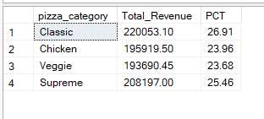

-- 4. % of Sales by Pizza Size

Select pizza_size, CAST (SUM (total_price) as decimal (10,2)) as Total_Revenue,
CAST (SUM (total_price) * 100 / (Select SUM (total_price) from pizza_sales) as decimal (10,2)) as PCT
from pizza_sales
Group by pizza_size
Order by pizza_size;

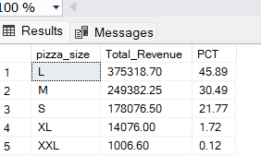

-- 5. Total Pizza Sold by Pizza Category

Select pizza_category, SUM (quantity) as Total_Quantity_Sold
from pizza_sales
Group by pizza_category
Order by Total_Quantity_Sold DESC;

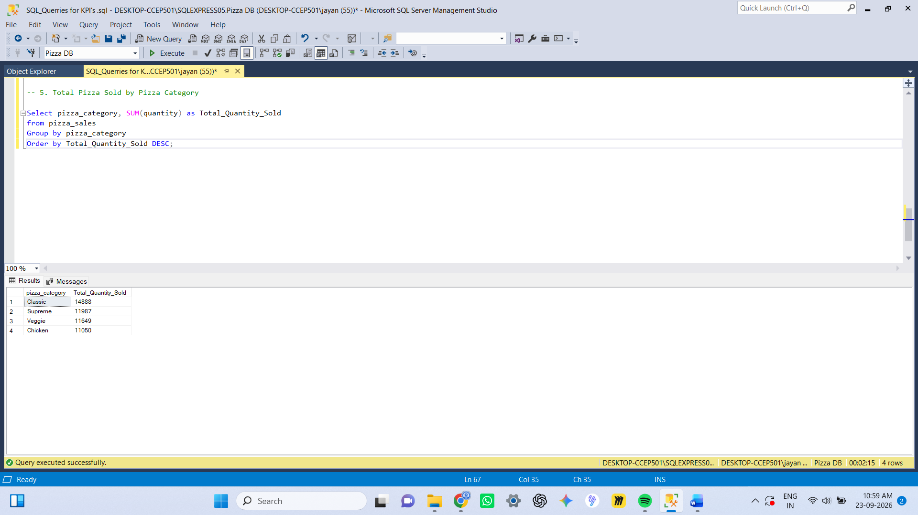

-- 6. Top 5 Best Sellers by Total Pizza Sold

Select Top 5 pizza_name, SUM (quantity) as Total_Quantity_Sold
from pizza_sales
Group by pizza_name
Order by Total_Quantity_Sold DESC;

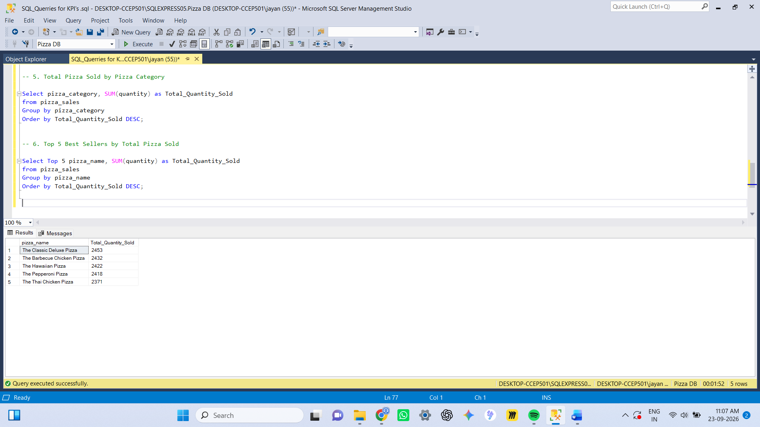

-- 7. Top 5 Worst Sellers by Total Pizza Sold
Select Top 5 pizza_name, SUM (quantity) as Total_Quantity_Sold
from pizza_sales
Group by pizza_name
Order by Total_Quantity_Sold ASC;

